LenuxParks
Smart Parking Platform

Aisha Fatusi
University of Houston
CIS 4374
Prof. Otto Dobretsberger
September 10, 2026

Table of Contents
1. Research 4
1.1 Driver-Facing Apps (Find/Book Parking) 4
1.2 Occupancy Sensors and Cameras 4
1.3 Garage/Lot Management Software 4
1.4 Opportunity for Differentiation 4
2. Vision & Scope 5
2.1 How the Project Came to Be 5
2.2 About Software Corp 5
2.3 Project Overview 5
2.4 Vision Statement 5
2.5 Scope 6
3. SRS 6
3.1 Introduction 6
3.2 Overall Description 6
3.3 Functional Requirements 7
3.4 Non-Functional Requirements 7
3.5 Use Cases 7
Use Case 1: Register and Create an Account 7
Use Case 2: Search for Available Parking 8
Use Case 3: Reserve a Parking Space. 8
Use Case 4: Pay for a Parking Reservation 9
Use Case 5: Navigate to a Reserved Parking Space 9
Use Case 6: Receive Reservation Notifications and Alerts 9
Use Case 7: Onboard a New Parking Facility 10
Use Case 8: Manage Facility Listing and Pricing 10
Use Case 9: Set Dynamic Pricing Rules Based on Demand 11
Use Case 10: View Occupancy Reports and Analytics 11
Use Case 11: Manage User Accounts & Platform Settings 11
Use Case 12: Configure Third-Party API Integrations 12
Use Case 13: Reconcile Payments & Manage Payouts 12
Use Case 14: Process a Digital Payment 12
Use Case 15: Access Aggregated Parking Usage Data 13
4. Work Breakdown Structure & Timeline 13

1. Research
The existing parking technology market was broken down into 3 categories, based on who each tool mainly serves. A tool built to help a driver find a spot faces different challenges, and different competitors than a tool built to help a garage owner manage pricing, or a tool that just tracks whether a space is open. The three categories are apps that help drivers find and book parking, sensor and camera systems that track real-time occupancy, and management software that helps parking owners handle pricing revenue and operations. Most existing platforms only do one of these three things. Very few combine all three which is where the opportunity for LenuxParks to stand out comes in.

Driver-Facing Apps (Find/Book Parking)
- SpotHero / ParkWhiz: These are easy to book ahead of time and have good coverage in big cities and at events, however, they only work with spots already listed in their system. For example, if a garage isn't in their network, it doesn't show up at all.
- ParkMobile: This is widely used for on-street and metered parking adopted by a lot of cities, but it's mainly pay by phone. Therefore, it’s not really built to help someone find an open spot.
- Google Maps/Waze: These are already installed on most phones and have decent crowd-based data in some cities, but they are not built for parking specifically. Additionally, there's no booking, pricing, nor reliable real time availability.

Occupancy Sensors and Cameras
- Cleverciti / Nwave: These use accurate real-time data used in physical sensors, but are expensive to install and slow to expand.
- Metropolis: This uses cameras and handles automatic payments; however, it still needs cameras installed at each location and the company is starting to buy and run garages directly instead of just selling the software.

Garage/Lot Management Software
- SKIDATA / TIBA/ Flowbird: These handle the full business side including gates, payments, and revenue reporting, and are trusted by large parking operators. However, older systems with outdated interfaces like these, aren't built giving thought to the driver experience.

Opportunity for Differentiation
None of the current platforms connect these three categories that have been broken down. The driver apps do not have real time occupancy data, the sensor companies do not interact with drivers directly, and the management software does not connect to either of the other two categories. That disconnect is the gap that LenuxParks can close, introducing one system that gives drivers real time availability and booking, while giving operators the same data to manage pricing and utilization

2. Vision & Scope

2.1 How the Project Came to Be
The idea for LenuxParks started with a common frustration. A Software Corp team member was in an unfamiliar city for a work trip and spent nearly 30 minutes circling a few blocks looking for parking for a meeting, arriving late despite leaving with plenty of time to spare. All the available tools were so disconnected and even though the map app helped get to the area, it had no idea what was actually open, and the nearest garage had no way to reserve a spot ahead of time or show real time availability.
That experience led to a conversation within the team about how existing parking tools each solve one piece of the puzzle, either finding a spot, tracking occupancy, or managing a garage's pricing, but none of them were doing all three. The idea was pitched internally and since it lined up well with the company's new rebrand direction, it was approved as an official project.

2.2 About Software Corp
Software Corp is a software development studio built to take on ambitious projects without the usual limits of developmental budget. Without those constraints, the studio can focus on building software that can solve a problem from end to end, rather than settling for a partial fix. LenuxParks is a direct result of that approach.

2.3 Project Overview
LenuxParks is a project focused on planning and managing the development of a software system that helps drivers locate, reserve, and pay for parking spaces at parking garages in real time. The platform will be delivered as a mobile application for drivers and a web-based dashboard for parking operators, providing live parking availability, navigation assistance, and management and analytics tools in one connected system. The project will delve into covering requirements gathering, stakeholder management, scheduling, budgeting, and risk management.

2.4 Vision Statement
LenuxParks eliminates the time drivers waste searching for parking by connecting real time availability, reservations and payments into a single experience while giving parking operators the visibility and tools needed to manage pricing and occupancy more effectively.

2.5 Scope
In scope (Phase 1, primary deliverable):
- Driver facing mobile app: Registration and authentication. Real time availability, interactive map reservations, digital payments, reservation history and receipts, notifications and alerts, navigation integration.
- Web-based administrative dashboard: occupancy reporting and analytics, operator management tools.
Out of scope (for now):
- Hardware or sensor installation for occupancy detection, assuming the system integrates with third party data sources.
- Physical garage infrastructure like gates or signage.
Constraints:
- Unlimited theoretical development budgets but a fixed semester timeline.
- Dependence on third party services and APIs. Including mapping and navigation, payment processing, etc.
- Must comply with data security and privacy requirements, along with applicable city ordinances and parking laws.

3. SRS

3.1 Introduction
Purpose: LenuxParks Helps drivers locate, reserve and pay for parking in real time, while giving operators tools to manage pricing, occupancy, and utilization.
Scope: Mobile app for drivers, Web dashboard for operators.

3.2 Overall Description
Users: drivers and vehicle owners. Mobile application users, parking operators, city transportation departments, system administrators, finance and billing personnel, third party payment providers.
Environment: mobile app (iOS/Android), web dashboard, third party APIs.
Constraints: unlimited budget but a fixed semester timeline, dependence on third party APIs, must meet data privacy and city ordinance requirements.

3.3 Functional Requirements
FR1: Secure registration and login.
FR2: Real time availability.
FR3: Interactive map.
FR4: Reservations.
FR5: Digital payment
FR6: Receipts.
FR7: Reservation History.
FR8: Admin dashboard.
FR9: Occupancy reports and analytics.
FR10: Notifications and alerts.
FR11: Navigation integration.
FR12: Admin accounts and settings management.
FR13: Payment reconciliation and payouts

3.4 Non-Functional Requirements
NFR1: Supports 1000+ concurrent users.
NFR2: Availability updates within 5 seconds.
NFR3: 99.9% uptime.
NFR4: Encrypted payments and personal data.
NFR5: Compliant with privacy laws and city ordinances.
NFR6: Map loads within 3 seconds.

3.5 Use Cases

Use Case 1: Register and Create an Account
Actor: Driver
Precondition: User does not have an account yet
Steps:
- User enters registration info.
- System validates and checks for a duplicate account.
- System sends a verification code.
- User confirms and the account is created.
Postcondition: User has a verified account and can log in.
User Story: “The driver I need to create a secure account so I can save my payment info and reservation history.
Acceptance Criteria: System rejects duplicates or invalid registrations. Verified accounts can log in immediately.

Use Case 2: Search for Available Parking
Actor: Driver
Precondition: User is logged in.
Steps:
- User enters a destination.
- System pulls real time availability from participating facilities.
- System shells results on the map with pricing and distance.
- User filters or sorts results.
Postcondition: User has a list of available parking options.
User Story: “As a driver, I need to quickly see what parking is actually available near where I'm going so I don't waste time guessing.”
Acceptance Criteria: Only currently available spaces are shown. Results update in real time.

Use Case 3: Reserve a Parking Space.
Actor: Driver
Precondition: User has found a facility.
Steps:
- User selects a facility and time window.
- System holds the space.
- User completes payment.
- System confirms the reservation.
Postcondition: The space is reserved and appears in the user's history.
User Story: “As a driver, I need to reserve a spot ahead of time so I know I'll have parking when I arrive.”
Acceptance Criteria: The space is held during payments. Reservation confirms only after successful payment.

Use Case 4: Pay for a Parking Reservation
Actor: Driver
Precondition: User has selected a space and time.
Steps:
- User select a payment method.
- System sends the transaction to the payment provider.
- Provider returns a result.
- System confirms and generates a receipt.
Postcondition: Payment is completed and linked to the reservation.
User Story: “As a driver, I need to pay for my parking directly in the app so I don't have to deal with cash or a separate kiosk.”
Acceptance Criteria: Both successful and failed payments are handled correctly.

Use Case 5: Navigate to a Reserved Parking Space
Actor: Driver
Precondition: User has an active reservation.
Steps:
- User selects the reservation.
- User taps to navigate.
- System opens directions through an external mapping service.
Postcondition: User is routed to the facility.
User Story: “As a driver, I need directions straight to my reserved spot, so I don't have to switch between apps to find it.”
Acceptance Criteria: Navigation launches directly from the reservation with the correct destination.

Use Case 6: Receive Reservation Notifications and Alerts
Actor: Driver
Precondition: User has an active or upcoming reservation.
Steps:
- System tracks reservation timing.
- System sends an alert at key points such as confirmation or an upcoming expiration.
- User taps the alert to view details.
Postcondition: User stays informed without checking the app manually.
User Story: “As a driver, I need to be alerted before my reservation starts or expires, so I don't lose track of time.”
Acceptance Criteria: Confirmation and reminder notifications are both sent correctly.

Use Case 7: Onboard a New Parking Facility
Actor: Parking Operator
Precondition: Operator has an administrative account.
Steps:
- Operator adds facility details.
- Operator connects an occupancy data source.
- System validates the information and activates the listing.
Postcondition: The facility is live and visible to drivers.
User Story: “As a parking facility operator, I need to add my garage to the platform and connect my occupancy data so drivers can start finding and reserving spots there.”
Acceptance Criteria: The facility does not go live until required data is provided.

Use Case 8: Manage Facility Listing and Pricing
Actor: Parking Operator
Precondition: Operator is logged into the dashboard.
Steps:
- Operator selects a facility.
- Operator updates pricing or availability.
- System reflects the change to drivers in real time.
Postcondition: Updated pricing and availability are live.
User Story: “As a parking facility operator, I need to update my pricing and availability in one place so drivers always see accurate information.”
Acceptance Criteria: Changes reflect in real time and are logged.

Use Case 9: Set Dynamic Pricing Rules Based on Demand
Actor: Parking Operator
Precondition: Occupancy data is connected.
Steps:
- Operator sets a trigger and an action, such as raising price by 15% once occupancy passes 80%.
- System applies the rule automatically as occupancy changes.
- Operator reviews the results and adjusts as needed.
Postcondition: Pricing adjusts automatically based on occupancy.
User Story: “As a parking facility operator, I need pricing to adjust automatically based on how full my garage is, so I can maximize utilization and revenue without manually updating prices all day.”
Acceptance Criteria: Price updates the moment a trigger is met. Operators can review and edit rules.

Use Case 10: View Occupancy Reports and Analytics
Actor: Parking Operator
Precondition: Operator is logged into the dashboard.
Steps:
- Operator selects a facility and date range.
- System shows occupancy trends, peak and slow times, and revenue.
- Operator uses the trend to make a decision, such as lowering evening pricing.
Postcondition: Operator has data to act on, not just a report to look at.
User Story: “As a parking facility operator, I need to see how full my garage gets and when, so I can adjust pricing and improve how I use my space.”
Acceptance Criteria: Trends are specific enough to points when action.

Use Case 11: Manage User Accounts & Platform Settings
Actor: System Administrator.
Precondition: User has an administrator role.
Steps:
- Administrator locates a user account or setting.
- Administrator makes a change.
- System applies and logs the change.
Postcondition: Accounts and settings reflect the update.
User Story: “As a system administrator, I need to manage user accounts and platform settings, so the system stays secure and runs smoothly.”
Acceptance Criteria: All administrative actions are logged.

Use Case 12: Configure Third-Party API Integrations
Actor: System Administrator.
Precondition: Administrator has valid API credentials.
Steps:
- Administrator ads or updates credentials for third-party service.
- System tests the connection.
- System confirms it is active.
Postcondition: The integration is active and available to the platform.
User Story: “As a system administrator, I need to manage our third-party API connections in one place, so integrations stay reliable and easy to update.”
Acceptance Criteria: Those connections are flagged clearly.

Use Case 13: Reconcile Payments & Manage Payouts
Actor: Finance and billing personnel.
Precondition: User has a finance role.
Steps:
- User reviews the transaction log from the payment provider.
- User resolves flagged discrepancies.
- User confirms payouts to operators.
Postcondition: Transactions are reconciled and payouts are processed.
User Story: “As a finance and billing team member, I need a clear view of all payment transactions, so I can make sure operators are paid correctly and disputes are resolved quickly.”
Acceptance Criteria: Discrepancies can be flagged and resolved.

Use Case 14: Process a Digital Payment
Actor: Third-party payment provider, triggered by a driver
Precondition: Driver has confirmed a reservation and entered payment details.
Steps:
- System sends the payment request to the provider.
- Provider returns a success or failure result.
- System updates the reservation and generates a receipt if successful.
Postcondition: Payment is processed and reflected in the records.
User Story: “As a driver, I need my payments to process securely and reliably, so my reservation is confirmed without issues.”
Acceptance Criteria: Both successful and failed responses are handled correctly.

Use Case 15: Access Aggregated Parking Usage Data
Actor: City Transportation Department.
Precondition: Department has an authorized reporting account.
Steps:
- Representative selects a facility, district or date range.
- System shows aggregated occupancy and usage trends.
Postcondition: City has data to support parking policy decisions.
User Story: “As a city transportation department, I need visibility into aggregated parking usage trends, so I can make informed decisions about local parking policy and infrastructure.”
Acceptance Criteria: Only aggregated, anonymized data is shown, never individual driver information.

4. Work Breakdown Structure & Timeline
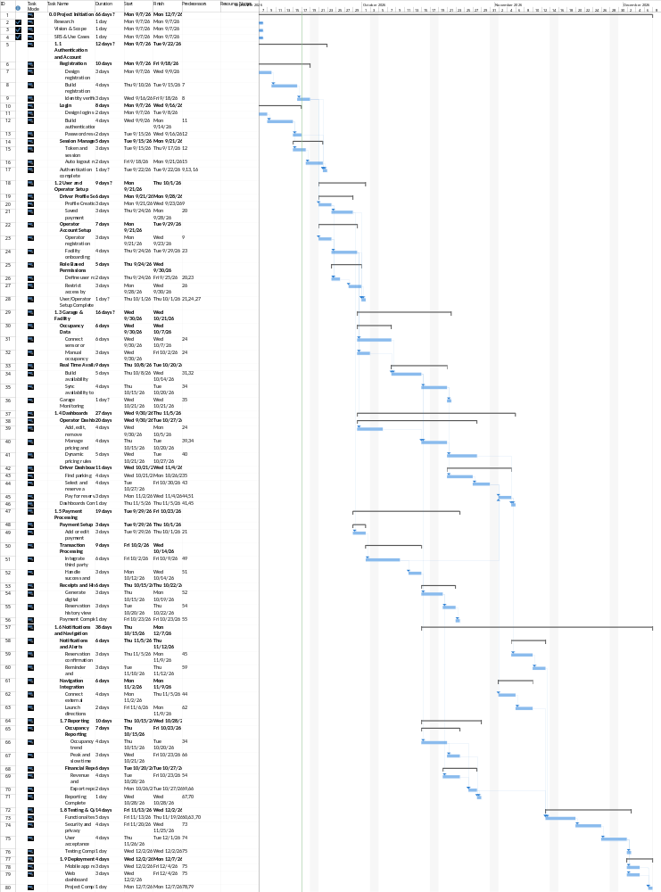
The work breakdown structure below organizes the LenuxParks project into its major components, including authentication, user and operator setup, garage monitoring, dashboards, payment processing, notifications and navigation, reporting, testing, and deployment. Each component is broken down into smaller tasks needed to complete it. The structure was built out in Microsoft Project, which also generated the Gantt chart shown below, mapping each task to a start and finish date based on its dependencies.

